Phase 1: Project Design

1. Describe the user interface. What are the menu options and how will the user use the application?
   1. The user interface is a menu driven interface that displays the menu when running the application. The menu options are as followed:
      1. Display Station name
      2. Display Station w/o Wheelchair Access
      3. Display Nearest Station
      4. Display information for a station with a specific name
      5. Display information for all stations
      6. Add a new station
      7. Delete an existing station
      8. Exit
2. Describe the programmers task:
   1. The programmers task is to figure out the process of designing, writing, testing, debugging/troubleshooting and maintaining the java code of the application. Also, the programmer designs a menu driven interface, in order to make it easier for a non-technical user to run the program.
3. Describe how you will read the input file.
   1. The input file will be read through a scanner, with providing a file extension in order for the scanner to recognise it as text-file, so it is read line-by-line.
4. Describe how you will process the data from the input file.
   1. Firstly we require a delimiter to separate out the values in the input file, in which an array String variable is created to store the values separated by commas, however before that is done, the scanner is used to skip a line of the file which displays the name of each column(Station name, latitude, longitude, location, wheelchair), in order to only retrieve the raw data.
5. Describe how you will store the data(what objects will you store?).
   1. The data will be stored in an arraylist through the CTAStation class, in which the data is firstly stored in an array of Strings as mentioned earlier and then we use an arraylist to store the objects and some of the objects such as the latitude and longitude is parsed to a double, and the wheelchair is parsed to a boolean.
6. How will you add/delete/modify data?
   1. The data will be added, deleted and modified by calling a method from the subclass(CTARoute class) to my main class.
7. How will you search the data?
   1. The data is search through a for loop, in which the arraylist is read through line by line depending on the station name entered, and if the name of the station is found then it would display the information of that particular station(latitude, longitude, location and wheelchair access).
8. List the classes you will need to implement your application.
   1. Main():
      1. CTAStopApp.java
   2. CTARoute():
      1. CTARoute.java
   3. CTAStation():
      1. CTAStation.java
   4. GeoLocation():
      1. GeoLocation.java
9. UML Diagram

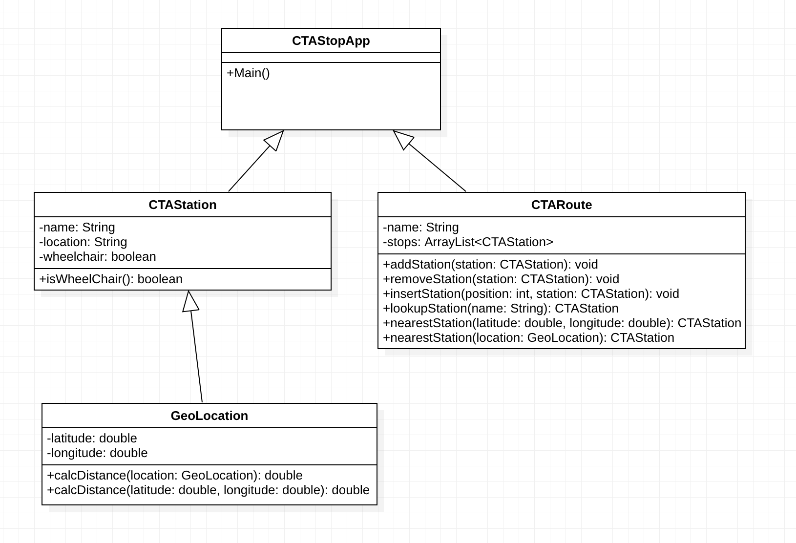

10. Think how you will determine if your code functions are expected. Develop a test plan based on the above description; how will you test that the expected outputs have been achieved? Be sure this test plan is complete. Your test plan should minimally test each option in the menu-driven user interface for expected behavior and error-resistance.

1. My test plan will have a table for each case in my application and firstly checks whether each of the functionality is performing efficiently and then it will validate the data to make sure the user does not enter invalid input.